Beskriv kort vilka lärdomar du kommer att ta med dig från det första projektet till projekt 2. Vad kommer du att göra annorlunda för att få projekt 2 att flyta bättre än projekt 1?
För det första var det mest feedback jag fick från läraren, vänner och familj. Jag visste den här gången med feedbacken att jag kan förbättra mig. För det andra kände jag att webbplatsen saknade lite struktur. Vilket betyder att vissa bilder inte matchade sammanhanget. Slutligen tror jag att jag skulle kunna skriva mer beskrivande dokumentation.

1. Brainstorma och hämta inspiration
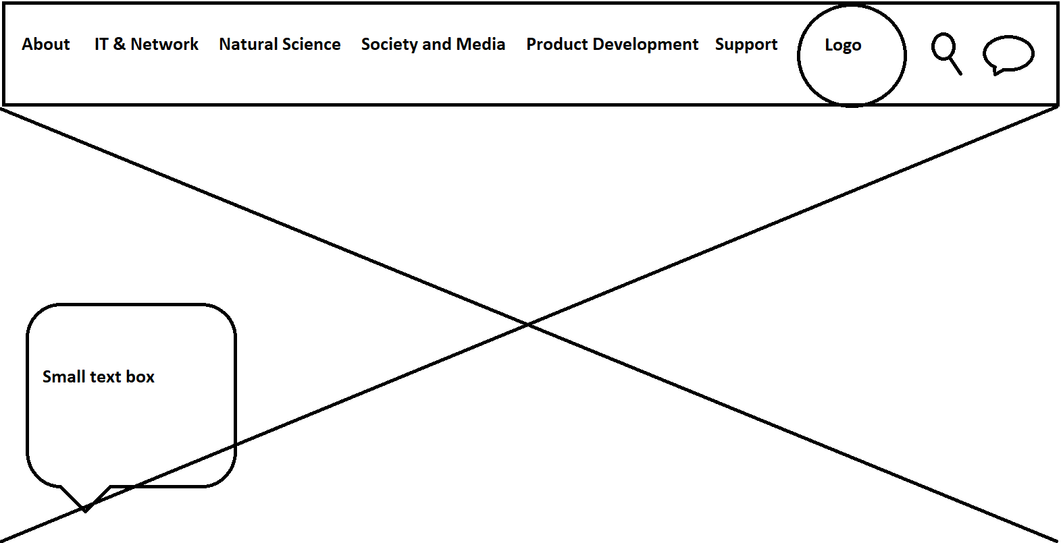
This is how I want my home page to look. I want it to be simple. I took inspiration from a lot of school websites since that's what I am going to work on. I feel like having a school website is like a school visit but digitally. This website can also oblige make user’s decisions more leisurely. (This is the brainstorm of my school home page on paint.)
Good and bad things about the websites for inspiration
Pros:
- Very simple design.
- Modern looks.
- Good colour combinations.
- The layout itself is very well laid.
- Easy to get around and get a hang of it.
- Its structure is inspired by Oxford University, Harvard University etc.
Cons:
- Not much I can say yet since I am still developing my skill and knowledge in this field. Each project I make is
- The best thing that I can take is the layout and how simple it is.

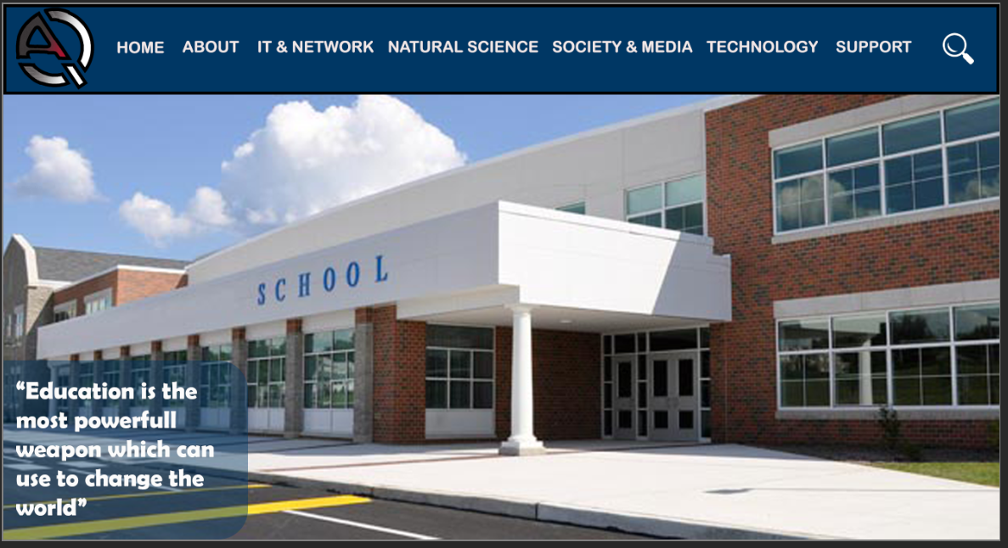
2. Skapa en projektplan!
Beskrivning av projektet:
- Vad är det för typ av hemsida du ska skapa?
- I wanted to make a school website. Since I feel like they are many elements you can code for.
- Vad är syftet med hemsidan? Vad ska den användas till?
- I believe that by making a school website I could design how a school website with. It will help kids to easily to get around and know how our school works.
Målgrupp:
- Vad har din målgrupp för förväntningar när de besöker din sida? (Tänk vanliga konventioner, dvs. Hur ”brukar det se ut” på liknande sidor, var placerar man exempelvis logga, meny, text, bilder etc.)
- My goal for expectations is that when they visit I want it to be a new experience and a website that they will remember for some time. I want them to feel special.
- Vilken är din målgrupp? Vilka ska besöka sidan?
- My first goal is that they should feel like they haven't seen any website like that.
- I also want my website to talk to them by knowing and fulfilling users’ requirements.
- A website with many simple menu bar options to give all information required.
- I want parents who are looking for a school which suits them the best.
- I also want students who need help applying for college.
Gränssnittet
- Beskriv med ord vad som ska finnas med på sidan samt hur du tänker dig att det ska presenteras visuellt.
- I want it to be sleek and simple. I believe I want it to be simple so most users can easily get around it.
- Hur kommer din design, layout och innehåll anpassas efter målgruppen?
- My design is modern with a regular menu bar as usual but overall my page has more options than more school websites.
- The layout is inspired by online templates, videos and images.
- The layout is also the longest part to do since I want my stuff to be symmetrical and not all over the place.
- The content targeted to my goals is also designed by feedback from my friends on what option might look better.
Lagar och etik
- Vilka lagar och etiska regler kommer du att behöva ta hänsyn till när du skapar och publicerar din hemsida och HUR tar du hänsyn till dessa?
- I will take care of copyright rules for my website since I used images from the internet.
- Probably images which I use I am going to take them off online. So I will probably after selecting the images do research if I could use those images to not get copyrighted.
- After selecting images I finally got permission and got allowed to use all images I used on my webpage.
Punktlista
- Gör en punktlista med saker som ska göras. En steg-för-steg-beskrivning av din arbetsprocess.
- First, I want to design the website on PhotoShop and Paint.
- Then I would design a website for link pages and the layout on PhotoShop and Paint as well.
- Then I would start coding visual code by writing the code in HTML and CSS.
- Firstly then I follow my wireframe and code homepage on Visual code.
- Secondly, I then follow my wireframes and code other pages on Visual code.
- Thirdly, I then code the links and add the link pages behind them on Visual code.
- Second and lastly, I finalised my code and ask my family for some feedback stuff.
- Lastly, I add the final touches to my code to finish my project.

3. Gör en wireframe (Photoshop)
När du har klart för dig vad det är för en hemsida som du ska bygga och vad du vill ha med på den är det dags att börja skissa på designen. Börja med en wireframe för att snabbt kunna bygga upp och få en överblick av den grundläggande layouten.

- Write the work process from idea to finished prototype. How did you go about it?
Background:
Firstly, I made a pre-planning on how this project will be executed by writing down a point list of the steps which I can then follow. Secondly, I then started by sketching how the home page will look on the paint. For how the homepage might look like I went on google to get some inspiration. I didn't make a wireframe on each page since there were many links and I had an idea of how they will look so didn't waste my time making a wireframe for each page. Thirdly, I then went on Unsplash and other sites where I can take images without worrying about copyright laws. Lastly, then I gathered all material required and started creating folders on my laptop so I have everything in one place. I also wrote a full of all the documentation for example pros and cons etc.

Coding process:
Firstly, I started coding for the homepage. When coding for the homepage I had a simple idea. Also, I spent the most time on getting the menubar and dropdown menu in right place and with all elements I want. I then finished off by adding an apply button and added my background image to finish my homepage.

Secondly, now I started working on the application page and it didn't take longer than 40min to finish it. I did take some help through videos online. After that I started coding for the contact page, for that, I already had the form from the application page and some details about our school from the previous project. Then I of course had to make a lot of changes for it to fit on the school website. Finally, I finished off with the application button and contact page.

Thirdly, I now started working with the blog page and events page together. The reason behind that both of them had a similar layout. This meant that if I finished one page and spent time on one page to get a fixed blog and events page I can easily code both of them. So I first started coding for the events page and looked at some tutorials to get a few tips and tricks on how the layout should be. I finally finalized the event page and copied my code to the blog page but there were a lot of pieces to change. Since the colour, text images and a bit of code needed to be changed for it to fit on the blog page. Lastly, I finished off by finalizing both pages.

Fourthly, I made code for the about page and with that page, I knew I would use the same context for all the courses, for example, social media etc. For about a page, it was probably the easiest of all since I had a template in my mind and some inspiration from online. I then finalized it by just having a simple bit of text and an image on the right side to make a good contrast. Then I took the same idea for all four-course pages. I of course made changes for all of the pages individually which matched their characteristics.

Lastly, I made the courses page which took the most time since I was inspired by the lightbox idea from one of the class lessons. Lightbox is written in javascript which I haven't worked with previously so it took some time to get a hang of. So I then took to the internet and downloaded the files required for my page. After downloading the files I had to make a lot of adjustments for the code to work. I then also had to work a lot on getting the image sizes right through photoshop and then of course needed to work a lot on CSS to get the images in the correct place. Overall I spent some time and with some knowledge I finished my courses page and was eventually finished with my website.

- Did you run into any problems along the way? Which? How did you solve these?
Yes, there are many points during this project where I needed help with problems. Some problems took fewer time others longer. The ones that took less time were just fixed with some help from google and the help of the teacher. Others needed some extra time and for those, I also ended up watching some video tutorials. The common problems were getting the menubar in the right place and the icons right. I had some issues with the margin on getting the items correct so there is no scrolling thing but still for two pages I couldn't fix it. With nearly all the problems I used w3schools and watched some video tutorials. Overall I, of course, spend time solving the problem for example how to inline texts or pictures. I also faced issues using the correct fonts and images for the right link.
The biggest problem was the lightbox on my webpage. There are still some issues with the size but mostly it's okay. I took help from the internet and I spent time just trying different tries to figure it out.

- How did you concretely adapt the website to your target group? (Be as detailed as
possible here)
Just trying to get the sizes right and the distance of the contents perfect to match my expectations. I also asked many of my friends and family members for feedback to get the perfect website for the users as possible. I also checked my website daily multiple times for me to check if I could change anything on the page. I also tried containing the same theme throughout the project. I also tried using the same font and colours to match my vision. I used photoshop to get the colour condition and the colour combination right. Then lastly figuring out the correct fonts and the perfect positions was difficult but it took some measurements to get them right.

- Which laws/regulations did you take into account in the work? How is this reflected in your content? Did you become
limited by this?
Yes, copyright rules over copied work on photos and so on. By taking and accepting regulations I instead used Unsplash and used some other websites which didn't put me at any risk for going against any laws and rules. I didn't become limited by the rules since I got the material that I visioned without facing any issues during this project from images to texts etc.

- Are you satisfied with the result? Why/why not?
Yes, I am super satisfied with my work and the effort and time I put into it I know how much I tried to make it the best site possible but maybe a bit more work on the contact page to get the scrolling issue fixed. I believe maybe a bit more knowledge might be required for that. But overall I worked more than I taught and I definitely surpassed my idea and thoughts.

Improvement suggestions! (Develop the answer!)
- If you were to do a similar project again, what do you think should be considered? Tips for yourself?
1. Spend more free time on coding getting some tips and finding shortcuts. Which will help me code more freely and take less time.

2. I would want to enjoy this process more rather than take the stress.

3. Learn more new tools in VS code so I could work more smother during this process. Because by knowing more tools I might use them to save time.

-Are there any pitfalls that can easily be avoided?
No, I don't think so. But maybe read through my code or when going live always be on the HTML side.

- Do you have any advice on strategy in terms of planning and implementation?
Just be super creative, do what you like and stay calm during the process of this project. While writing the code I think you should do each thing step by step. Since if you mix it all up it will give you a headache for real. Just be simple and enjoy each step.

- Did you need to broaden your knowledge in html and CSS to be able to build the page you wanted?
Not really but extra knowledge is never useless, I believe I got most of the stuff done and maybe a bit more practice and knowledge could have helped to make the website even more perfect. There is always room for improvement in everything and I believe I could also improve

- Other thoughts and reflections.
Not really, just enjoyed this and would like to do more of these projects in the future. I think these projects are really good since getting a full chance on showing your full potential and the level of your skills. Lastly, I believe every project I do, I show more skills and more knowledge meaning that each project is better than before.

